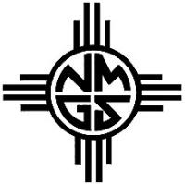
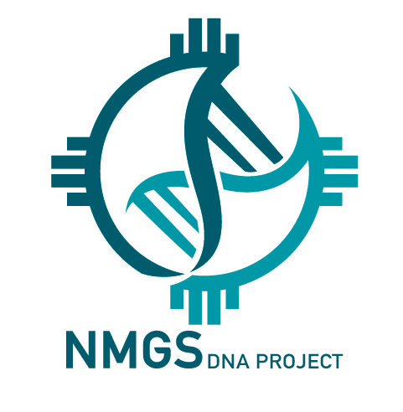
Please fill out the below form and email to dna@nmgs.org

THE PROJECTS GOAL:
The goal of the NMGS DNA Project is to use the genealogies and DNA results to better understand New Mexican ancestry by managing them in a database listing last known ancestors for the lines tested. To accomplish this, the project is designed to be open with sharing genealogies and DNA results. This in turn helps New Mexico genetic genealogy as a whole. In order to fulfill our commitment to list the earliest known ancestor for each kit, we request participants to provide NMGS DNA Group Project Administrators Advanced Access to their DNA Kit.

REQUIREMENTS TO JOIN PROJECT:
- Applicant Questionnaire and Request to Join the NMGS DNA Project
- Read and sign the Terms of Conditions, Privacy Policy and Consent to Participate in NMGS DNA Project
- Submit a Lineage form for validation by one of the NMGS DNA Project volunteers
If a participant does not adhere to the requirements above, administrators have the right to remove them from the project.
Applicant Questionnaire and Request to Join the NMGS DNA Project
Name of person who tested: Kit number:
Email:
Phone: Mobile:
I manage my own DNA kit Yes/No:

I have assigned a Kit manager to act as my agent to manage my DNA kit:
Name of Kit manager:
Email:
Phone:
NMGS DNA Project Administrator Internal Use
Received by:
Validated by: Returned to participant by:

TERMS AND CONDITIONS
By Signing and Submitting this form, you agree to, and give the following consent:
The intent of the NMGS Genetic Genealogy project (NMGS DNA) is to provide genetic and genealogical information for family lineages that link to people who settled in New Mexico. Please initial:
- By participating in the NMGS DNA Project I agree to allow my DNA results to be compared with that of others in order to find potential relationships with other project participants, the origins of my ancestors, and other purposes contributing to the historical understanding of early settlers. ________ Initial

- I understand the project managers will not provide me with personal analysis of my DNA results. My results will be aggregated with the results of other project members to discover and document information on the ancestral lines that settled in New Mexico prior to the 1900s or within 100 years. ________ Initial

- I understand that DNA tests can reveal unexpected results. Genealogists understand that DNA test results, like traditional genealogical records, can reveal unexpected information about the tester and his or her immediate family, ancestors, and/or descendants. For example, both DNA test results and traditional genealogical records can reveal misattributed parentage, adoption, health information, previously unknown family members, and errors in well-researched family trees, among other unexpected outcomes. ________ Initial

- I understand that I must order and pay for my own DNA test, purchased from FamilyTreeDNA. ________ Initial

- I agree for myself, and on behalf of all my family and heirs to release NMGS DNA from any liability, claims, demands or causes of action, and not to sue or make other claims against NMGS whatsoever arising from my participation in the NMGS DNA Project. ________ Initial

- I assume full responsibility for any risk occurring from my participation. I agree to indemnify and hold NMGS harmless from all claims, judgments, expenses and costs, including but not limited to attorney’s fees, incurred in connection with any claims brought as a result of my participation in the project which are released by the terms of this agreement. ________ Initial
PRIVACY POLICY
- I understand that complete privacy protection cannot be guaranteed at any time the Internet and connected devices are used, but reasonable efforts will be made to ensure privacy. ________ Initial

- NMGS may publish my lineage or lineage of the person tested in such a manner that personal information for living persons is omitted. Persons born more than 100 years ago are assumed to be deceased. I understand that NMGS will not publish my name, phone number, or email address in articles. And the names of living persons in my lineage will also be privatized in any publications. ________ Initial

- Once my lineage validation form is returned to me, I agree that if I should decide to share this lineage form, that I am responsible for removing personal information about myself and my kit manager. I shall hold harmless NMGS, NMGS DNA Project, NMGS DNA Group Project Administrators andLineage Validators from any risk or liability for injury that may be be caused from my decision to share this document. ________ Initial

- Subsequent to my death, I consent to the refinements of my test and new tests to be ordered by administrators of the NMGS DNA Project. I further understand these results will be published in a manner that respects my consent preferences above. ________ Initial
Signature of Kit owner: Date:
Signature of Kit manager: Date:
Y-DNA LINEAGE

Haplogroup:

Save the document as a .doc so that validation team can insert their comments into the blocks. Documents sent as a .pdf format will not be accepted.

Generation #1 – Person Tested | Date/Event | Source Material
Name of person tested |  | Per applicant

Generation #2 – Parents | Date/Event | Source Material
Father of Generation #1
and name of his wife

Generation #3 – Grandparents | Date/Event | Source Material
Father of Generation #2
and name of his wife

Generation #4 | Date/Event | Source Material

Generation #5 | Date/Event | Source Material

Generation #6 | Date/Event | Source Material

Generation #7 | Date/Event | Source Material

Generation #8 | Date/Event | Source Material

Generation #9 | Date/Event | Source Material

Generation #10 | Date/Event | Source Material

Generation #11 | Date/Event | Source Material

Generation #12 | Date/Event | Source Material

Generation #13 | Date/Event | Source Material

Generation #14 | Date/Event | Source Material

Generation #15 | Date/Event | Source Material

If you have additional information, insert in comments below. The block will expand as you type.

COMMENTS:

