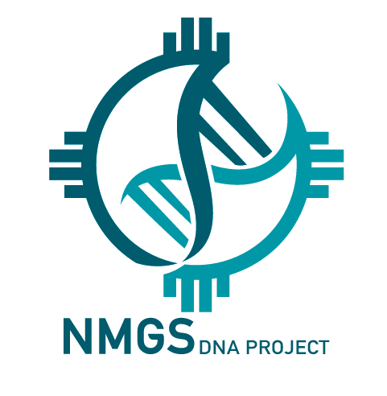
NMGS DNA Project
mtDNA Lineage Form

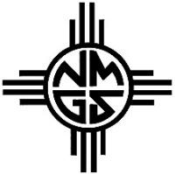
Purposes of This Form
- Voluntary Member Submission: Members may share an earliest known ancestor or a matrilineal and/or patrilineal lineage if they wish. This submission is not required to join the NMGS DNA Project.
- Internal Administrator Verification: Administrators may use this form when conducting a lineage verification for a specific research question, cluster analysis, or surname study.
Name of person tested:
Email:
Phone: Mobile:
I manage my own DNA kit (circle one): Yes/No

I have assigned a Kit manager to act as my agent to manage my DNA kit (circle one): Yes/No
If yes, name of Kit manager:
Email:
Phone:
If you include a Y-DNA or mtDNA lineage form, please use the following documentary style to prove relationship from each generation to the next, when you submit your form. Each generational link should be supported with records such as baptisms, marriages, premarital investigations, census entries, or other primary sources.
mtDNA Lineage Form - Example
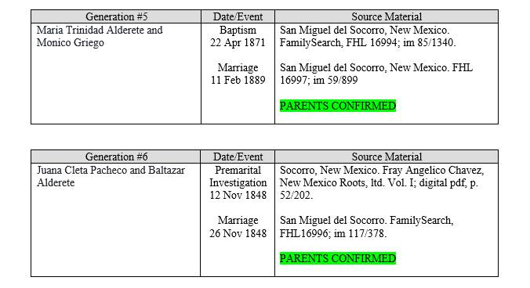

mtDNA
Haplogroup:

Generation #1 – Person Tested | Date/Event | Source Material
Name of person tested

Generation #2 – Parents | Date/Event | Source Material
Mother of Generation #1
and name of her spouse

Generation #3 – Grandparents | Date/Event | Source Material
Mother of Generation #2
and name of her spouse

Generation #4 | Date/Event | Source Material

Generation #5 | Date/Event | Source Material

Generation #6 | Date/Event | Source Material

Generation #7 | Date/Event | Source Material

Generation #8 | Date/Event | Source Material

Generation #9 | Date/Event | Source Material

Generation #10 | Date/Event | Source Material

Generation #11 | Date/Event | Source Material

Generation #12 | Date/Event | Source Material

Generation #13 | Date/Event | Source Material

Generation #14 | Date/Event | Source Material

Generation #15 | Date/Event | Source Material

If you have additional information, insert in the comments below.
The block will expand as you type.

COMMENTS:

